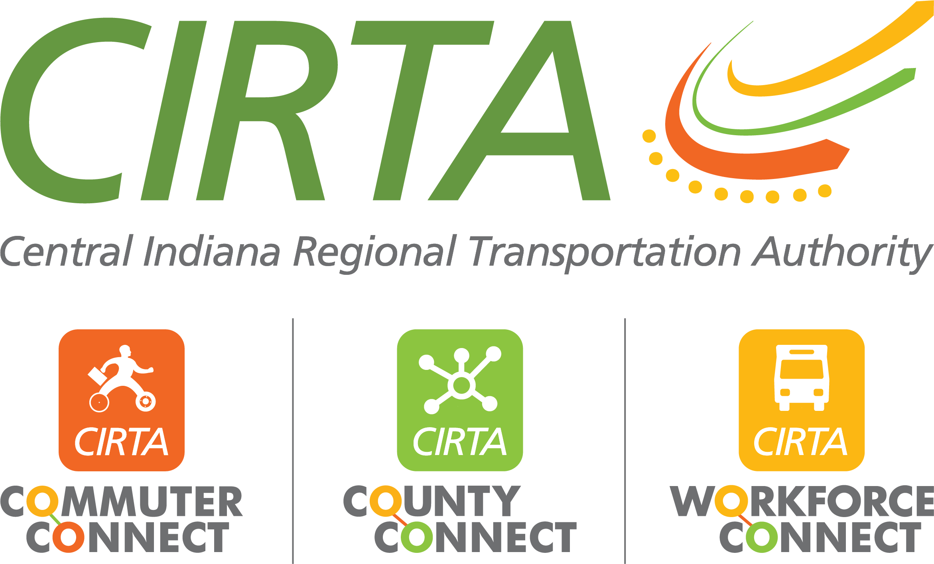
320 N. Meridian St., Suite 920
Indianapolis, IN 46204
317-327-7433
www.cirta.us

2024 CIRTA Board Meeting Dates
9am – 11:00am

- February 13, 2024 – CIRTA Office – 320 N. Meridian Street, 9th Floor, Indianapolis, IN 46204
- April 16, 2024 – IndyGo East Campus – 9503 E. 33rd Street, Indianapolis, IN 46235
- June 11, 2024 – Community Health Pavilion Saxony – 13121 Olio Road, Suite 240, Fishers, IN 46037
- August 13, 2024 – Community Health Pavilion Washington – 7910 East Washington Street, Suite 310, Indianapolis, IN 46219
- October 15, 2024 – CIRTA Office – 320 N. Meridian Street, 9th Floor, Indianapolis, IN 46204
- December 10, 2024 – American Structurepoint – 9025 River Road, Suite 200, Indianapolis, IN 46240

