Central Indiana Regional Transportation Authority (CIRTA)
June 11, 2024, 9:00am
Community Health Pavilion Saxony
13121 Olio Road
Fishers, IN 46037

Board Members Present: |  | Board Members Not Present | CIRTA Staff Present
Destiny Wells (v) | Jerry Bridges (v) | Linda Sanders | Jennifer Gebhard
Larry Hesson * | Christine Altman | Cam Starnes | Amanda Meyer
Greg Henneke  Ron Deer (v) | Ann Sheidler  Don Adams* | Andrew Klineman | Sarah Troutman  Sebastian Caicedo
Mike Goralski ^
Robert Waggoner
Kyleen Swackhamer (v)

*Larry Hesson and Don Adams arrived at 9:20 am
^Mike Goralski arrived at 9:46 am

The board meeting was called to order at 9:09 am by G. Henneke.
J. Gebhard took roll call and ensured a quorum was present.

Resolution #2024-06-11-01– Adoption of Consent Agenda

C. Altman made a motion to accept the consent agenda items. R. Waggoner seconded. Roll call was taken.

Ron Deer- yea
Greg Henneke-yea
Robert Waggoner-yea
Jerry Bridges-yea
Christine Altman-yea
Ann Sheidler-yea
Kyleen Swackhamer-yea
Destiny Wells-yea

No opposition, the motion was carried.

Resolution #2024-06-11-02 – Resolution to Approve Contract Amendment with TransPro
- TransPro Consulting has been working on the Workforce Connector Study with CIRTA
- Recommended that the remaining funds, not to exceed $28,000, be used for TransPro for procurement support.

R. Waggoner made a motion to approve resolution to approve the contract amendment with TransPro, A. Sheidler seconded. Roll call was taken.

Ron Deer- yea
Greg Henneke-yea
Robert Waggoner-yea
Jerry Bridges-yea
Christine Altman-yea
Ann Sheidler-yea
Kyleen Swackhamer-yea
Destiny Wells-yea

No opposition, the motion was carried.

Presentation: ProPEL Indy – ProPEL Indy Team
ProPEL Indy is a 2-year transportation study with a unique opportunity for residents, neighborhoods, businesses, and commuters to envision the future of I-65 and I-70 in Indianapolis.

Study area:
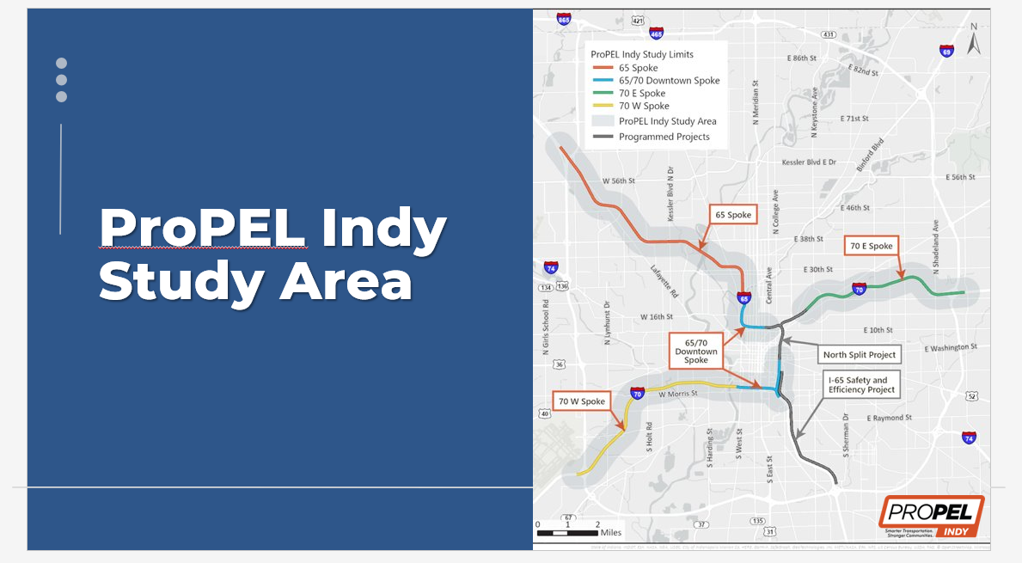

Study Schedule:
- Spring ’23 – Spring ’24 – Visioning/data collection
- Summer ’23 – Spring '24 – Identify needs based on data analysis and initial public input
- Winter ’24 – Summer ’24 – Identify alternatives that address needs
- Winter ’24 – Summer ’24 – Alternative development and cost estimation
- Fall ’24 – Spring ’25 – Development of study recommendations

Visioning Phase:
- Spent the last year asking for public ideas about the future of I-65 and I-70.
  - 1,104 Public Comments
  - 620 Stakeholders
  - 45 Committee Members
  - 61 Engagement Events
- Study Pillars
  - Quality of Life and Livability
  - Economic Growth & Opportunity
  - Transportation and Mobility
  - Equity
- Data Driven, fueled by feedback
  - Bridge and pavement conditions
  - Crash data and roadway operations
  - Current and projected traffic volumes
  - Previous studies & environmental constraints
- Draft Purpose and Need Report – released on May 20th
  - Transportation Issues – Aging bridge and pavement conditions, Roadway safety, Roadway mobility, and Limited multimodal & neighborhood connections.
- The purpose of ProPEL Indy is to identify potential solutions to:
  - Improve aging bridges and pavement
  - Improve safety along and at intersections near the interstates by reducing the frequency and/or severity of crashes
  - Reduce congestion and improve mobility by address operational and geometric deficiencies
  - Improve multimodal connectivity across and near the interstates
- Community Goals
  - Quality of Life & Livability – Identify community enhancements that improve the quality of life of adjacent neighborhoods.
  - Economic Growth & Opportunity – Provide transportation infrastructure to support local, regional, and statewide economic development goals.
  - Transportation & Mobility – Support emerging technologies and related infrastructure. Consider INDOT’s carbon reduction strategy, national electric vehicle infrastructure plan, and future Resilience Plan alternative development.
  - Equity – Actively engage stakeholders who use, cross, work, or live near the interstates throughout the study. Provide accessible, fair, safe, affordable, reliable, and sustainable mobility along and across interstates for community members based on identified needs and input received.
- Next Steps
  - Draft Purpose & Need Report is available for public comment through June 30, 2024
  - Multiple outreach and engagement activities scheduled in June
  - Alternative Identification & Development

There were several questions asked by CIRTA board members.
- Was there input from the Rethink Coalition – Indy members? Yes, there is an advisory committee, and they are part of that.
- Is there thought of limiting through traffic through town or Park & Ride options? This is something the study will be looking into.
- Study will be completed in about a year? Yes, with public engagement throughout each phase of the study.
- Now that IndyGo’s Blue Line is using part of I-70, what accommodations will be made? We are coordinating with IndyGo but there are no answers yet.
- CIRTA’s Whitestown Workforce Connector route uses 465 & 865. Is that part of this study. No.
- Is there any coordinating study with 465? 465 is not the main focus of this study, though it is recognized that traffic is a system and work on I-65 & I-70 could have ramifications. That impact will be looked at. The main focus is inside the loop on I-65 & I-70.
- Will the recent improvements to the North Split be revisited? The North Split is outside of the study but will not be ignored if improvements need to be made with the study results. The South Split is included in ProPEL Indy.
For more information or to submit feedback visit https://propelindy.com/
Public comments close 6/30/2024

Legislative Update

- Expansion of the EID goes into effect July 1st with opt out option.
- Summer interim committees to watch – The State and Local Tax Review Taskforce and Funding Indiana Roads for a Stronger Safer Tomorrow Taskforce.
- Looking ahead to the next session, what needs CIRTA would like to pursue?
  - Dedicated Funding for CIRTA. Will need a budget line.
  - It was decided to for a small committee of CIRTA board members to work with the legislative team on getting dedicated funding.
- Governor’s Office CIRTA Board appointments are still in the works. Since there will be a new Governor next year, these positions are difficult to fill currently. The legislative team will continue to work on these.

Executive Update

- CIRTA has completed NTD, Grant season, and the annual audit
- The CIRTA team is fully staffed, and Amanda and Sebastian are doing great in their new roles.
- New CMAQ funding.
  - New Federal Exchange Program
  - Previously, CIRTA would apply for funding through the IMPO and then put the funds received into a grant and then draw it down.
  - Starting October 2024, CIRTA will receive funding directly through the IMPO.
  - CIRTA will receive those funds in 6 month increments and send receipts to the IMPO.
  - This 3-year agreement has been reviewed by the legal team and is for $2.2 million.
  - CIRTA will receive 100% with no match needed and is the special exception in the region.

Christine Altman made a motion to approve the 3-year agreement with IMPO for CMAQ funds, Greg Henneke seconded.
Ron Deer- yea
Greg Henneke-yea
Robert Waggoner-yea
Jerry Bridges-yea
Christine Altman-yea
Ann Sheidler-yea
Larry Hesson-yea
Destiny Wells-yea
Don Adams-yea
Mike Goralski-yea

- CIRTA had one AFR ding on their Annual Audit that had a zero net effect. As a corrective action CIRTA will revise the approval process.
- CIRTA has begun to implement the new Strategic Plan
  - Changing from a blanket communication to separate communications for CIRTA Champions and CIRTA commuters and employers
  - Relaunching the corporate challenge for Car Free Day
- CIRTA office is under renovation for two weeks.
- Jennifer and Amanda are heading to Ohio to meet with the Mid Ohio Regional Planning Commission to learn more about their vanpool program and their Mobility Management network.
- Jennifer introduced Mike Goralski to the Board.

Mobility Management Update

- Amanda has been attending partner meetings
  - Presented to the Work One team in Plainfield
  - Meeting with Visit Hendricks County
- The 5307 Grants are completed
- NTD Annual is completed
- Ridership is up – Plainfield had 1,259 riders in May, Whitestown had 536 riders.
- Amanda attended a two-day FTA Drug and Alcohol training
- CIRTA has 10 cross-county trip requests in May
- County Connect continues to work on regionalized options for easy of cross counties trips
- County Connect is finalizing the pilot program between Hamilton County and Hancock County.
- My Freedom Program trips continue to increase with 78 trips in May.

Commuter Connect Update

- 420 new commuters bringing the total to 11,863 in the database
- Hosted over 50 information tables at employers since the last meeting
- Attending weekly orientations at Full Beauty Brands, Southpointe Healthcare, Walgreens Micro Fulfillment, and Hostess.
- Community Events include Transit Center tabling, IMPO Southeast District Community Day, and several Earth Day events
- Presented to the Indianapolis Urban League and Easterseals Crossroads.
- The Leadership Team has been involved with the Excel Center and TWI Taskforce Roundtable.
- 6 new mentors for our Bike Buddy Program
- Planned and attended Bike to Work Day with Bike Indianapolis and attended Bike to Work Day with Bike Carmel
- CIRTA will have 10 school participating in School Pool this fall.
- 6,233 new users to the website in April & May
- 13,928 web views
- 2,167 impressions on LinkedIn

Ron Deer made it known that he did not make it through the primary and this fall may be his last meeting. He has enjoyed his 20+ years working with CIRTA. Greg Henneke thanked Ron for his service.

Jerry Bridges wanted to reiterate the need for looking at transit alternatives and neighbor connectivity in the ProPEL Study. CIRTA can provide input to that study. Any way we can improve the environment is worthwhile.

Christine Altman stated when looking at adding value, CIRTA can look at community connections such as neighborhoods and churches in areas of transportation needs and facilitate employers to those groups for vanpools.

Adjournment

The motion was made to adjourn the meeting by L. Hesson and seconded by D. Adams at 10:36 am.
All in attendance agreed.

