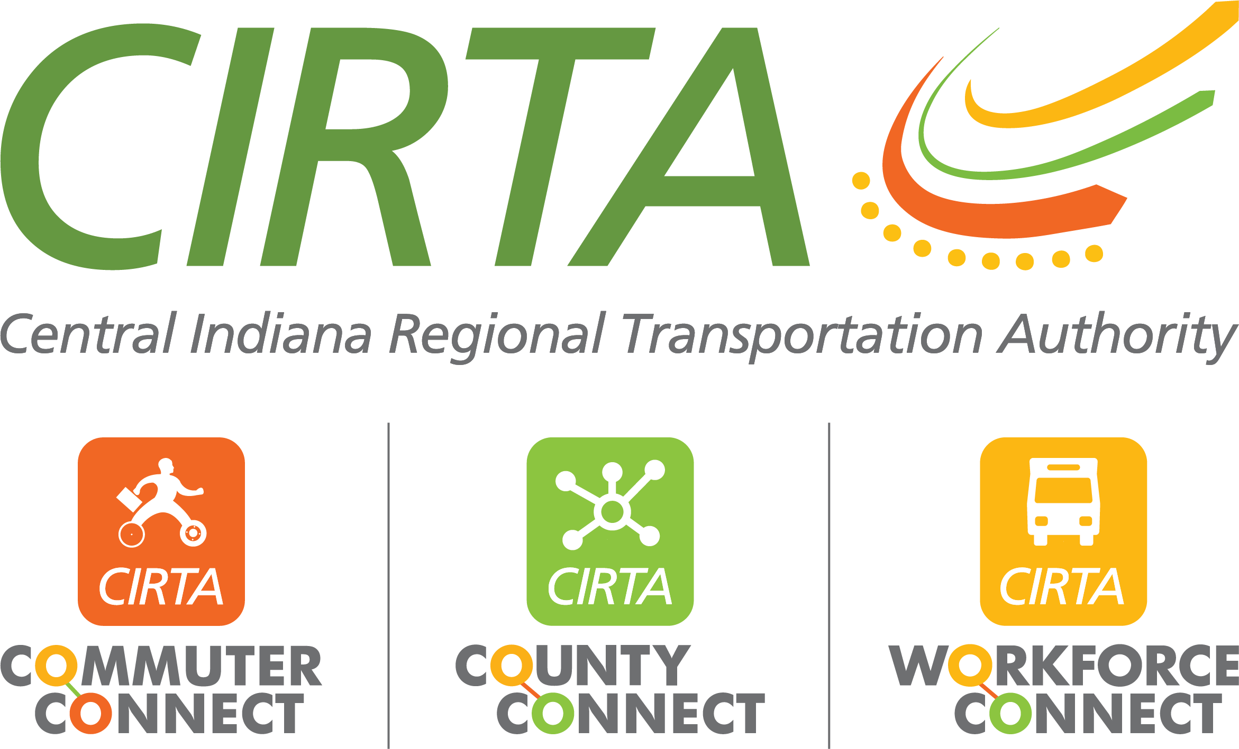
320 N. Meridian St., Suite 920
Indianapolis, IN 46204
317-327-7433
www.cirta.us

2025 CIRTA Board Meeting Dates
9am – 11:00am

- February 11, 2025 – CIRTA Office – 320 N. Meridian Street, 9th Floor, Indianapolis, IN 46204
- April 8, 2025
- June 10, 2025
- August 12, 2025
- October 14, 2025
- December 9, 2025

