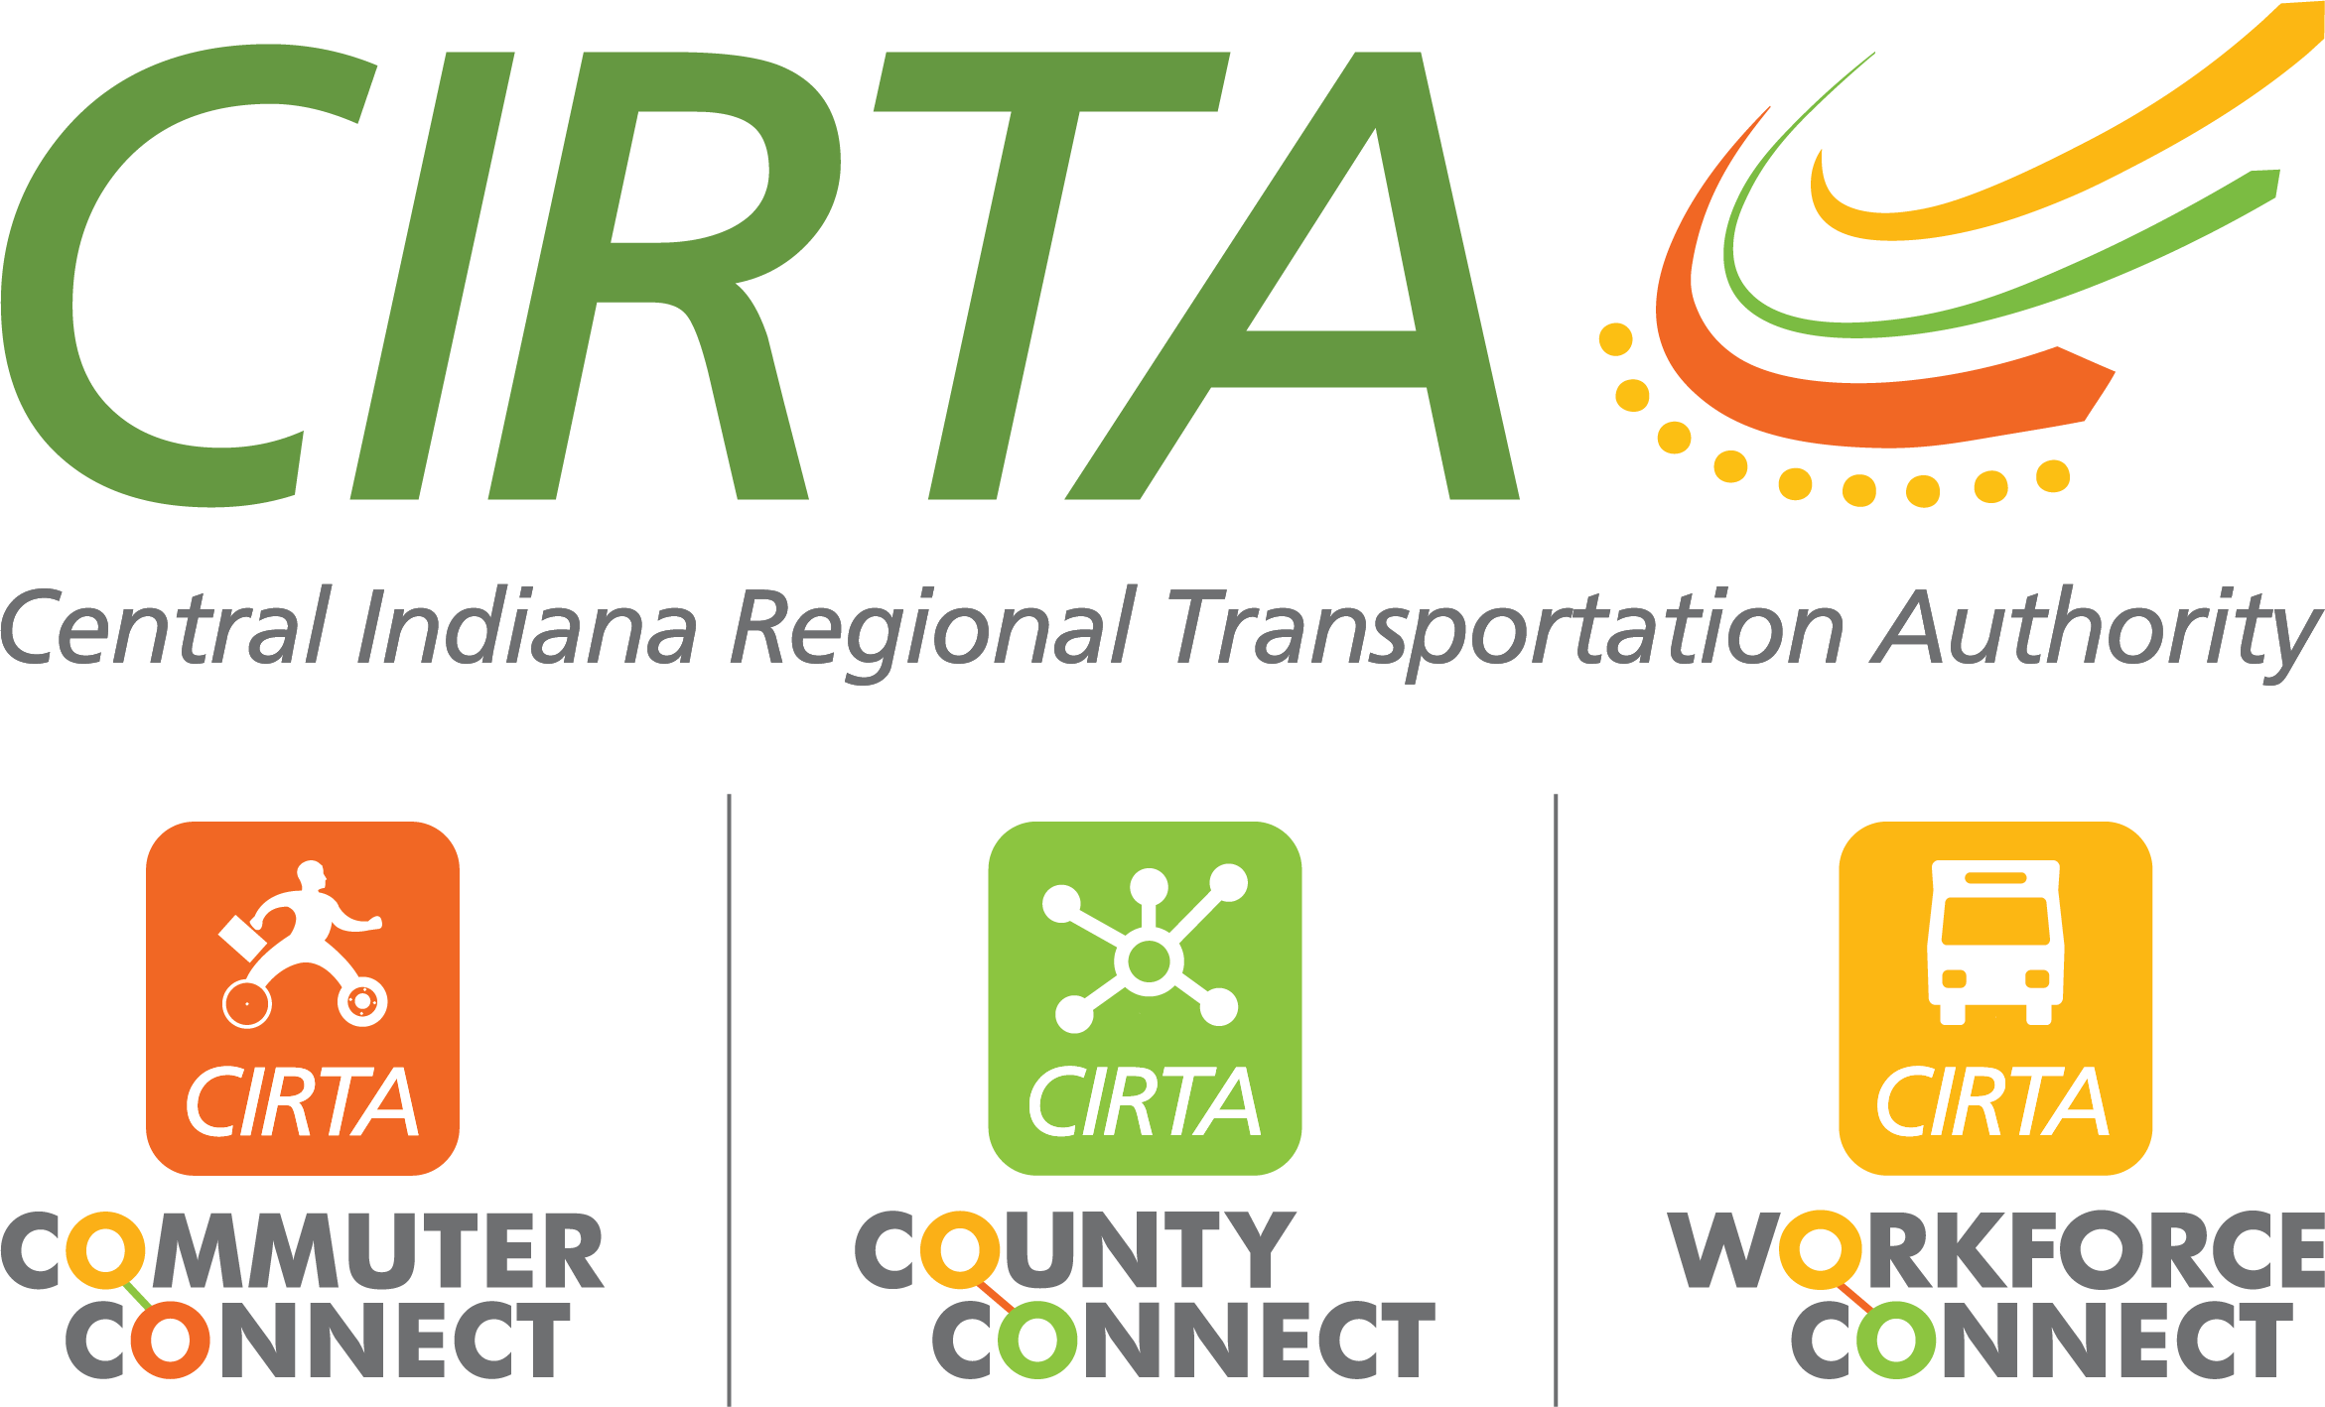
320 N. Meridian St., Suite 920
Indianapolis, IN 46204
317-327-7433
www.cirta.us

2026 CIRTA Board Meeting Dates
9am – 11:00am

February 10, 2026 – CICOA
i8440 Woodfield Crossing Blvd #175, Indianapolis IN 46240

April 14, 2026 – Hancock County Senior Services
1870 Fields Blvd, Greenfield, IN 46140

June 09, 2026 – IndyGo
1501 W. Washington Street, Indianapolis, IN. 46222

August 11, 2026 – Janus
1555 Westfield Rd, Noblesville, IN 46062

October 13, 2026 – Chamber of Commerce Building
320 N. Meridian Street, 9th Floor conference room, Indianapolis, IN 46204

December 8, 2026 – American Structurepoint
9025 River Road, Suite 200, Indianapolis, IN 46240

